

|  |
| --- |
| Experiment No. 7 |
| Implement Booth’s algorithm using c-programming |
| Name: Vishwatej Sarang |
| Roll Number: 51 |
| Date of Performance: |
| Date of Submission: |

**Aim:** To implement Booth’s algorithm using c-programming.

**Objective -**

1. To understand the working of Booths algorithm.
2. To understand how to implement Booth’s algorithm using c-programming.

**Theory:**

Booth’s algorithm is a multiplication algorithm that multiplies two signed binary numbers in 2’s complement notation. Booth used desk calculators that were faster at shifting than adding and created the algorithm to increase their speed.

The algorithm works as per the following conditions :

1. If Qn and Q-1 are same i.e. 00 or 11 perform arithmetic shift by 1 bit.

2. If Qn Q-1 = 10 do A= A - B and perform arithmetic shift by 1 bit.

3. If Qn Q-1 = 01 do A= A + B and perform arithmetic shift by 1 bit.

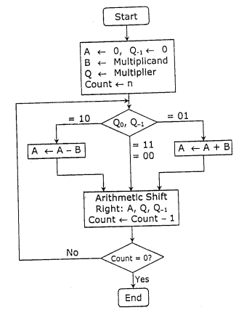

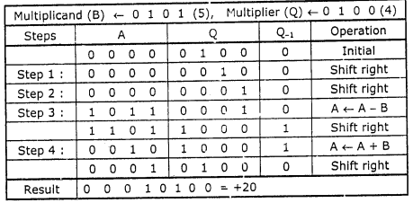

**Program:**

**#**include <math.h>

int a = 0,b = 0, c = 0, a1 = 0, b1 = 0, com[5] = { 1, 0, 0, 0, 0};

int anum[5] = {0}, anumcp[5] = {0}, bnum[5] = {0};

int acomp[5] = {0}, bcomp[5] = {0}, pro[5] = {0}, res[5] = {0};

void binary(){

a1 = fabs(a);

b1 = fabs(b);

int r, r2, i, temp;

for (i = 0; i < 5; i++){

r = a1 % 2;

a1 = a1 / 2;

r2 = b1 % 2;

b1 = b1 / 2;

anum[i] = r;

anumcp[i] = r;

bnum[i] = r2;

if(r2 == 0){

bcomp[i] = 1;

}

if(r == 0){

acomp[i] =1;

}

}

c = 0;

for ( i = 0; i < 5; i++){

res[i] = com[i]+ bcomp[i] + c;

if(res[i] >= 2){

c = 1;

}

else

c = 0;

res[i] = res[i] % 2;

}

for (i = 4; i >= 0; i--){

bcomp[i] = res[i];

}

if (a < 0){

c = 0;

for (i = 4; i >= 0; i--){

res[i] = 0;

}

for ( i = 0; i < 5; i++){

res[i] = com[i] + acomp[i] + c;

if (res[i] >= 2){

c = 1;

}

else

c = 0;

res[i] = res[i]%2;

}

for (i = 4; i >= 0; i--){

anum[i] = res[i];

anumcp[i] = res[i];

}

}

if(b < 0){

for (i = 0; i < 5; i++){

temp = bnum[i];

bnum[i] = bcomp[i];

bcomp[i] = temp;

}

}

}

void add(int num[]){

int i;

c = 0;

for ( i = 0; i < 5; i++){

res[i] = pro[i] + num[i] + c;

if (res[i] >= 2){

c = 1;

}

else{

c = 0;

}

res[i] = res[i]%2;

}

for (i = 4; i >= 0; i--){

pro[i] = res[i];

printf("%d",pro[i]);

}

printf(":");

for (i = 4; i >= 0; i--){

printf("%d", anumcp[i]);

}

}

void arshift(){

int temp = pro[4], temp2 = pro[0], i;

for (i = 1; i < 5 ; i++){

pro[i-1] = pro[i];

}

pro[4] = temp;

for (i = 1; i < 5 ; i++){

anumcp[i-1] = anumcp[i];

}

anumcp[4] = temp2;

printf("\nAR-SHIFT: ");

for (i = 4; i >= 0; i--){

printf("%d",pro[i]);

}

printf(":");

for(i = 4; i >= 0; i--){

printf("%d", anumcp[i]);

}

}

void main(){

int i, q = 0;

printf("\t\tBOOTH'S MULTIPLICATION ALGORITHM");

printf("\nEnter two numbers to multiply: ");

printf("\nBoth must be less than 16");

//simulating for two numbers each below 16

do{

printf("\nEnter A: ");

scanf("%d",&a);

printf("Enter B: ");

scanf("%d", &b);

}while(a >=16 || b >=16);

printf("\nExpected product = %d", a * b);

binary();

printf("\n\nBinary Equivalents are: ");

printf("\nA = ");

for (i = 4; i >= 0; i--){

printf("%d", anum[i]);

}

printf("\nB = ");

for (i = 4; i >= 0; i--){

printf("%d", bnum[i]);

}

printf("\nB'+ 1 = ");

for (i = 4; i >= 0; i--){

printf("%d", bcomp[i]);

}

printf("\n\n");

for (i = 0;i < 5; i++){

if (anum[i] == q){

printf("\n-->");

arshift();

q = anum[i];

}

else if(anum[i] == 1 && q == 0){

printf("\n-->");

printf("\nSUB B: ");

add(bcomp);

arshift();

q = anum[i];

}

else{

printf("\n-->");

printf("\nADD B: ");

add(bnum);

arshift();

q = anum[i];

}

}

printf("\nProduct is = ");

for (i = 4; i >= 0; i--){

printf("%d", pro[i]);

}

for (i = 4; i >= 0; i--){

printf("%d", anumcp[i]);

}

}

**Output:**

BOOTH'S MULTIPLICATION ALGORITHM

Enter two numbers to multiply:

Both must be less than 16

Enter A: 10

Enter B: 2

Expected product = 20

Binary Equivalents are:

A = 01010

B = 00010

B'+ 1 = 11110

-->

AR-SHIFT: 00000:00101

-->

SUB B: 11110:00101

AR-SHIFT: 11111:00010

-->

ADD B: 00001:00010

AR-SHIFT: 00000:10001

-->

SUB B: 11110:10001

AR-SHIFT: 11111:01000

-->

ADD B: 00001:01000

AR-SHIFT: 00000:10100

Product is = 000001010

**Conclusion -**

In conclusion, the Booth algorithmis a helpful technique for binary multiplication of signed integers in the 2's complement representation. Compared to conventional multiplication techniques, the process just requires shifting and either adding or removing the multiplicand based on the multiplier bit*value*. We have supplied a bitwise operation-based implementation of Booth's method in C along with a practical application